KUTC JOINT PROJECT INTERIM ASSESSMENT REPORT
Assessment Period 26/11/2019 – 25/06/2020
Combined Report (KU + External Research Partners)
Do not exceed a total of 3 pages
Project Details
Budget Code: | 8474000259
KUTC Reference
Full Project Title: | Development of solid electrolytes for harsh environment batteries
Principal Investigator: | Daniel Choi
Co-Investigators:
Research Staff: | Prerna Chaturvedi
PhD Student(s):
MSc Student(s):
Project Start Date: | 26/11/2019 | Project End Date: | 25/11/2022
External Collaborator | Hae Jin Kim (KBSI in South Korea)
KU Budget Allocation | (AED) 1,101,750 for 3 years
Partner Budget Allocation | (AED) 1,102,000 for 3 years
Total Project Budget | (AED) 2,203,750 for 3 years

Total Project Budget per Fiscal Year (AED)
2019 | 2020 | 2021 | 2022
31,750 | 367,250 | 367,250 | 335,500

Actual Expenditure to Date (AED)
2019 | 2020 | 2021 | 2022
4,520 | 35,000

Summary of Project & Deliverables to date (min. 1 / max. 2 pages) + Gantt Chart (Plan vs Progress)

Task 1. Development of LITFSI in PYR14TFSI ionic liquid based gel polymer electrolyte
In this time period, PVDF-HFP based polymer electrolyte were prepared by using using two different strategies (mentioned below). The morphological, electrical, mechanical, thermal and electrochemical performance of electrolyte were studied.

PVDF-HFP based membrane cum solid polymer electrolyte
Firstly, specific amount of urea was dissolved in 15 ml dimethylformamide (DMF), using magnetic stirrer for one hour. Later, PVDF-HFP, was added in the above solution to form a viscous polymer solution. Then the mixture was stirred overnight and tape casted on a clean glass plate with 1 mm blade gap and dried at 120 °C for 6 hours to obtain a polymer membrane. The porous membrane was de-attached from the glass plate and acted as separator for coin cells. Four different samples with and without urea were prepared for different urea to PVDF-HFP ratio. The morphological, thermal, mechanical and electrochemical properties of various membrane with LTO-CNT based buckypaper were investigated.

The PVDF-HFP based polymer membranes were prepared via tape-casting method using urea as a pore creating agent. The highest amount of pores and its volume was obtained in PM66 which facilitates highest electrolyte uptake resulting in improved electrochemical performance. Further, good thermal and mechanical properties were confirmed with DSC and DMA analysis. To investigate electrochemical performance and compatibility of polymer membrane with flexible LTO electrode, GCD, CV and EIS were performed. The improved electrochemical performance of PM66 affirmed its role as a potential separator material in flexible Li ion batteries.

PVDF-HFP and Ionic liquid based electrolyte
Poly(vinylidenediflouride-co-hexafluoropropylene) (PVDF-HFP) based polymer electrolyte have been prepared. Solution A was prepared as 1 M LiTFSI in PYR14TFSI by using 0.574 g of LiTFSI in 2.86 g of PYR14TFSI and stirred for 4 hours. Solution B was prepared by using 0.5 g of PVDF-HFP in 5 ml acetone and stirred for 4 hours. Later, 2.5 g of Solution A was added slowly in Solution B and stirred for 4 h. The gel like solution has been obtained. Then the solution was drop casted on glass petri dish and let it dry for 2 days. Later, the film was put for vacuum drying to remove any moisture content for 2 days. The obtained film was cutted in 19 mm and used as electrolyte for further characterization.
Literature was reviewed for the fabrication of garnet based nanocomposite polymer electrolyte.

Task 3. Development of porous CNT nanocomposite by freeze casting method
To prepare porous carbon nanotube (CNT) nanocomposites, at first, the CNT slurry used in the freeze-casting was prepared by adding 100 mg of CNTs (10%) to a solution of 10 mL of de-ionized water and 10 mL of ethanol. Then the mixture was ground using a mortar and pestle for 2 minutes. Afterward, 30 ml of de-ionized water was added to the slurry. The slurry was sonicated using a VCX 750 Ultrasonic Processor (Sonic, USA) and magnetic stirring was conducted by advanced hotplate stirrers (VWR, USA). The processes above were simultaneously performed at room temperature. An amplitude of 40% was set for 10 minutes, with mixing at 500 rpm for the first 2 minutes and 800 rpm for the remaining 8 minutes. The sonication process must maintain a 30 Watts power and energy >18000 Joule. Then, the dispersed slurry was then casted at room temperature using a micrometer adjustable film applicator (EQ-Se-KTQ-150, MTI Corporation, USA) with a doctor-blade gap of 7 mm. The matt-side of the copper foil (EQ-bccf-9u, MTI Corporation, USA) was used as the supporting substrate. The copper foil was placed on top of a glass plate (EQ-Tglass, MTI Corporation, USA) with the matt side of the copper foil on the top.
The casted film was placed in the freezer at -20 C for six continuous hours. After that, the frozen film was move immediately to the freeze dryer (Labconco 4.5 L Cascade) to evaporate water and ethanol content from the samples, this process is performed under vacuum at -105 C. The sample was removed from the freeze dryer after 24 continuous hours. Mechanical tests and measurements of porosity of the produced porous CNT nanocomposites are in progress.

Tasks/Milestones | Year 1 |  |  |  | Year 2 |  |  |  | Year 3
Task 1: Development of LITFSI in PYR14TFSI ionic liquid based gel polymer electrolyte (KU)
Progress
Task 2: Development of Li superionic conductor solid electrolytes (KBSI/ YHK, JGK, MYS)
Progress
Task 3: Development of porous CNT nanocomposite by freeze casting method (KU)
Progress
Task 4: Testing half-cells (KBSI/WGH,JGK)
Task 5: Modelling and simulation of the solid electrolytes - SEI formation (KBSI/HJK)
Progress
Task 6: Thermal analysis of solid electrolytes (KU)
Task 7: Fabrication of full-cell batteries (pouch cell) – single cell (KU/KBSI/WGH,YHK)
Task 8: Fabrication of full-cell batteries (pouch cell) – multiple cells, stacked batteries (KU/KBSI/WGH)
Task 9: Testing/demonstration of full-cell batteries (pouch cell) as a prototype for EV battery (KU/KBSI/WGH)
Task 10: Harsh environmental tests of prototype full cell batteries (KBSI/WGH, JGK)

Challenges Faced & Mitigation Plan (up to 500 words)

The main motivation of the work is to prepare solid polymer electrolyte with high conductivity and good compatibility with CNT based electrode materials. In this time period, we have tried various method to fabricate the electrolyte. We will also try to introduce some fillers in the electrolyte to improve its ionic conductivity. In future, our focus will be to investigate the electrochemical performance of the prepared electrolyte with CNT based electrodes.

For Garnet based nanocomposite electrolytes, we will be focusing to synthesize two to three different materials and incorporate those material in freeze casting to fabricate porous structure. Later, the prepared structure will be used with appropriate polymer to produce composite polymer electrolyte.

Summary of External Research Partner Contributions to Date (min. 500 words per Partner)

Task 2 & 5. Dr. Kim's group developed flexible all-solid-state batteries with a capacity of about 100mAh/g by applying composite electrodes and polyethylene oxide (PEO)-based solid electrolyte. The developed all-solid-state batteries were fabricated as a full cell, which consisted of LiFePO₄ (LFP) as a negative electrode, graphite as a positive electrode, and PEO-based solid electrolyte.
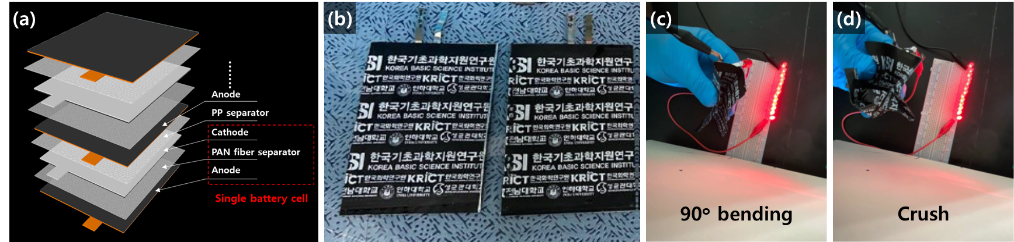
Figure 1. (a) Schematic illustration of the configuration of the LFP/PEO-based solid electrolyte/Graphite full cell. (b) Digital image of pouch-type full cells. Digital image of flexible all-solid-state batteries turning on light-emitting diodes (LED) under (b) bending and (c) crushing.
Their electrochemical performance shows about 90% capacity retention during 50 cycles of charge and discharge, and about 88% capacity retention even after 1000 bending tests. In addition, the stacking technique was applied to internal composite electrodes for improving the energy density of all-solid-state batteries. Dr. Kim’s group is also continuously developing novel solid electrolyte and next-generation all-solid-state batteries which are closely related to this project.
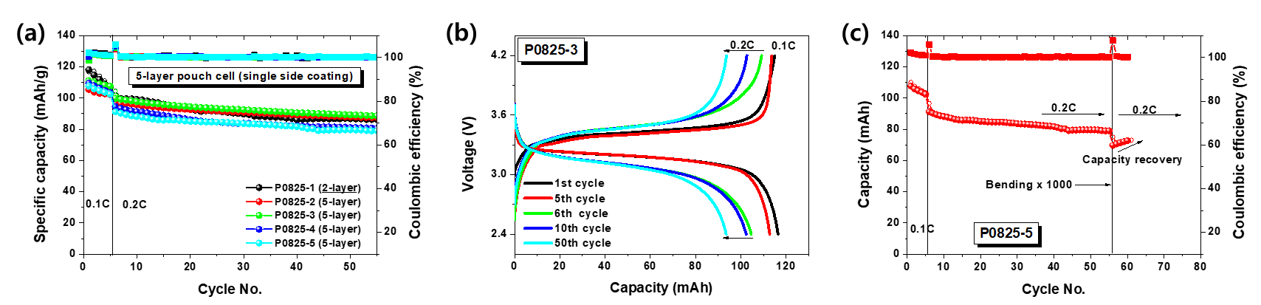
Figure 2. (a) Cycling performances and (b) charge-discharge curves of flexible all-solid-state batteries at current densities of 0.1C for 5 cycles followed by 0.2C for 50 cycles. (c) Capacity retention after 1000 times bending tests.
The codes has been being developed for modelling of simulation of the electrolytes based on Monte Carlo simulation tool and Molecular Dynamics. Density Function Theory (DFT) is also being utilized for developing the codes.
Research plan (KBSI)
Dr. Kim's group will carry out collaborative research mainly on the synthesis and application of solid electrolytes which are for extreme environments. Recently, sulfide-based solid electrolytes including Li₁₀GeP₂S₁₂ (LGPS) are attractive as the most promising candidate materials owing to their high ionic conductivity similar to those of organic electrolyte. This work will be devoted to 1) Modification of the structural composition of LGPS to improve ionic conductivity suitable for extreme environment. 2) Mass production of solid electrolytes through scale-up by overcoming the limitations of conventional synthesis process.
Joint project meetings: The teams have met and discussed on the progresses and issue of the project work four times via on-line platform during the reporting period. Student/researcher exchanges between two institutes have been prevented due to pandemic.
** Only outputs specifically referencing this KUTC award by way of acknowledgment of funding will be considered an award output **
Project Output Data – Specific to this Project during the report period
Journal Publications (Include full reference details including DOI)
KU Sole Authors | P. Chaturvedi, A, Kanagaraj, A. Alhammadi, H. Alshibli, D. Choi, “Fabrication of PVDF-HFP-based microporous membranes by the tape casting method as a separator for flexible Li-ion batteries”, submitted to the Journal of Composite Materials, 2020 (In review)
KU + Project Partners (Joint) Authors
Project Partners Sole Authors

Conference & Workshop Presentations (Include presentation title, event name, month/year)
KU Sole Presenter
KU + Project Partners (Joint) Presenters
Project Partners Sole Presenter

Invention Disclosures – Files/Granted Patents (filing reference / patent number)
KU Sole Inventor
KU + Project Partners (Joint) Inventors
Project Partners Sole Inventor
Other Project Outputs (optional)

